1. This question is about while Number from 1 to 10. A Possible world is an integer;
   1. Determine the possible worlds for the sentence: x is odd; {1}, {3}, {5}, {7}, {9}
   2. Prove or disprove the following
      1. X is even And x is Prime != x is equal to 2;
         1. Possible words for the first second {2}
         2. Word for possible second: {2}
         3. Model of alpha is 2 and model of Betha is 2
   3. Prove or disapprove the following
      1. X is odd or x is prime != x is less than 7
         1. X is odd or is prime = {1,2,3,5,7,9} {model of alpha}
         2. X is less than 7 {1,2,3,4,5,6}; (model pf Betha)
         3. Because model of alpha is not a subset of model of beta, there is no a entertainment;

3) We need to draq 7 different wayt

5) every time there is no a top left mine and botton right mine; There are 4 combinations; Ij all cases [1,2[ does not contains a main: true;

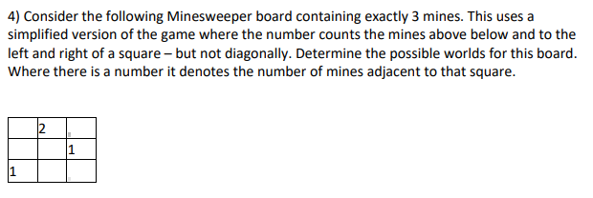

1. There is a mine at [1,3] (top left) ╞ There is a mine at [3,1] (bottom right) (ii) There is a mine at [1,2] ╞ there is not a mine at [2,1]

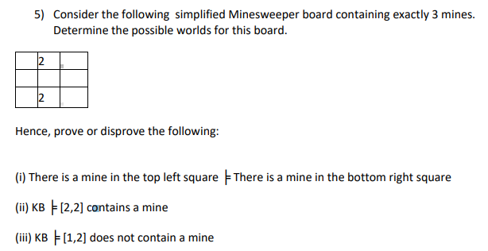

6) Consider the following values of variables:

P= FALSE

Q= TRUE

R= FALSE W

hat is the value of each of the following statements? a)

(¬P Ù ¬Q) Ù R b) (P Ù Q) Ú ¬R. c) (P Ù ¬Q) Ù ¬R d) (¬P Ú Q) Ù ¬R e) (¬P Ù Q) Ù R

Dijkstra\*:

Uniform cost search or Dijkstra algorithm? Speak between difference between uniform cost search or Dijkstra;

A\* search – uniform cost search are different algorithms; but Dijkstra and uniform cost search are almost the same

Goal-based “ A\*